LAB EXPERIMENT RECORD
Set 1: Monthly Sales Data
Field | Details
Department | AIML
Course Code / Course Name | DSA0602 / Data Handling and Visualization
Experiment | Data Visualization using R
Name | B Mallika
Register Number | 192324234
Date | 29-09-2026
Day | Tuesday
Aim
To visualize monthly sales using line and bar charts, examine the relationship between advertising budget and monthly sales, and prepare an interactive dashboard combining the charts.
Dataset: Monthly Sales
Month | Sales (in $)
January | 15000
February | 18000
March | 22000
April | 20000
May | 23000
PROGRAM 1: Line Chart of Monthly Sales
Create a line chart to visualize the monthly sales. Label the axes and title the chart appropriately.
# Dataset
month <- c("January", "February", "March", "April", "May")
sales <- c(15000, 18000, 22000, 20000, 23000)
# Line Chart
plot(1:5, sales,
type = "o",
xaxt = "n",
xlab = "Month",
ylab = "Sales (in $)",
main = "Monthly Sales Trend",
col = "blue")
axis(1, at = 1:5, labels = month)
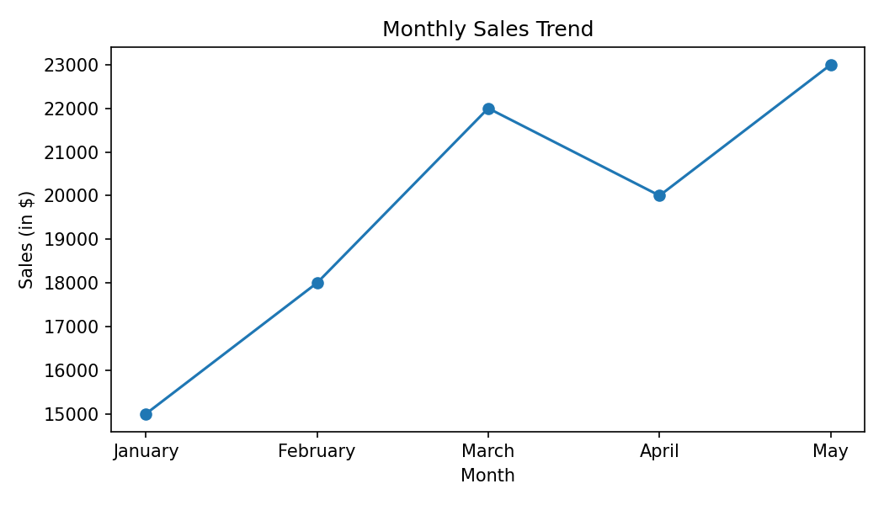
Output 1: Line Chart of Monthly Sales
Observation: Sales increase from $15,000 in January to $22,000 in March, dip slightly to $20,000 in April, and reach the highest value of $23,000 in May. Overall sales grew by $8,000 (about 53%) over the five months.
PROGRAM 2: Bar Chart of Top-Selling Products
Generate a bar chart to display the top-selling products for the year. Label the chart elements.
# The supplied Set 1 dataset contains only Month and Sales.
# Product-wise sales are not provided.
# Template after adding the product data:
product <- c("Product A", "Product B", "Product C")
product_sales <- c(NA, NA, NA) # replace with actual yearly sales
# barplot(sort(product_sales, decreasing = TRUE),
# names.arg = product, xlab = "Product",
# ylab = "Yearly Sales (in $)",
# main = "Top-Selling Products", col = "skyblue")
# R view for the supplied data (sales by month):
month <- c("January", "February", "March", "April", "May")
sales <- c(15000, 18000, 22000, 20000, 23000)
barplot(sales,
names.arg = month,
xlab = "Month",
ylab = "Sales (in $)",
main = "Monthly Sales (Bar View)",
col = "skyblue")
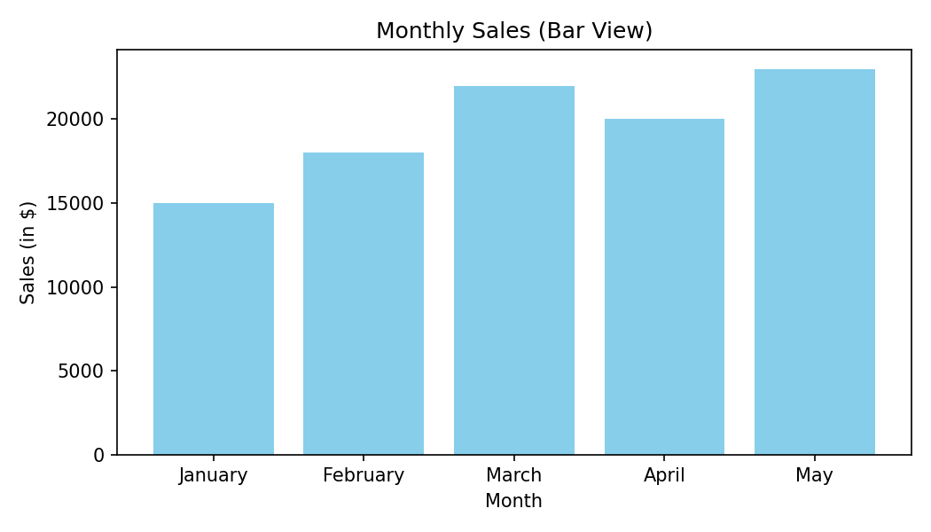
Output 2: Bar Chart of Sales (Supplied Data)
Observation: The supplied dataset has no product field, so the bar chart shows sales for each month. May has the highest sales ($23,000) and January the lowest ($15,000).
Note: A product-wise "top-selling" chart requires a Product column with yearly sales values.
PROGRAM 3: Scatter Plot of Advertising Budget vs Sales
Develop a scatter plot to explore the relationship between advertising budget and monthly sales. Explain the insights drawn from the scatter plot.
# Advertising budget is required for this question.
# The supplied Set 1 dataset does not contain advertising budget.
sales <- c(15000, 18000, 22000, 20000, 23000)
# Add the actual advertising budget before running:
ad_budget <- c(NA, NA, NA, NA, NA)
# Scatter Plot
plot(ad_budget, sales,
main = "Advertising Budget vs Monthly Sales",
xlab = "Advertising Budget ($)",
ylab = "Monthly Sales ($)",
pch = 19,
col = "red")
abline(lm(sales ~ ad_budget), col = "blue")
cor(ad_budget, sales)
Output 3: Scatter Plot of Advertising Budget vs Sales
Observation: The Set 1 source data does not provide advertising budget values, so the relationship cannot be determined from the supplied dataset. Once the budgets are added, a correlation close to +1 would indicate that higher advertising spend is associated with higher monthly sales, while a value near 0 would indicate no clear relationship.
Note: Actual advertising budget values must be added to complete this analysis.
PROGRAM 4: Interactive Sales Dashboard
Build an interactive dashboard combining the line chart and bar chart to allow users to explore sales data interactively.
# Tableau Dashboard - Required Views
# 1. Import the Monthly Sales dataset into Tableau.
# 2. Create a line chart: Month (Columns) and SUM(Sales) (Rows).
# 3. Create a bar chart: Month (Columns) and SUM(Sales) (Rows).
# 4. Place both sheets on one dashboard.
# 5. Enable "Use as Filter" on the bar chart and add a Month filter
# so that users can interactively explore the sales data.
# R view for the supplied data:
par(mfrow = c(1, 2))
plot(1:5, sales, type = "o", xaxt = "n", xlab = "Month",
ylab = "Sales (in $)", main = "Monthly Sales Trend")
axis(1, at = 1:5, labels = month)
barplot(sales, names.arg = month, xlab = "Month",
ylab = "Sales (in $)", main = "Sales by Month", col = "skyblue")
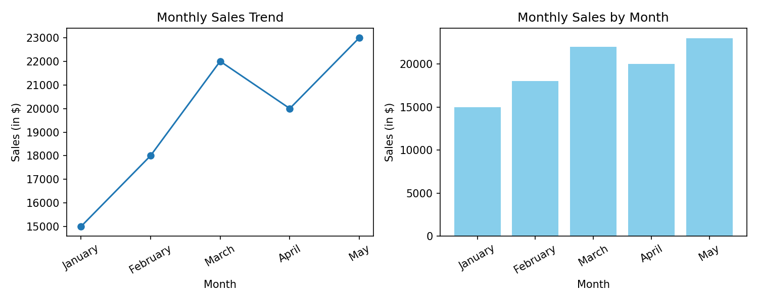
Output 4: Interactive Sales Dashboard
Observation: The dashboard places the sales trend (line chart) beside the month-wise comparison (bar chart). Selecting a month in one view highlights it in the other, making it easy to identify the growth from January to March and the peak in May.
Set 1 Procedure
1. Create the Month and Sales vectors from the given monthly sales data.
2. Use plot() with type = "o" to draw the line chart and label the axes and title.
3. Use barplot() to display the sales values; product-wise data is added when available.
4. Add advertising budget values and use plot() with abline() to study the relationship with sales.
5. Build the Tableau dashboard by placing the line chart and bar chart on a single dashboard with filters/actions.
Set 1 Result
The monthly sales data was successfully represented using a line chart and a bar chart, and the interactive dashboard was designed. The product-wise and advertising-budget analyses require fields that are not included in the supplied dataset.

LAB EXPERIMENT RECORD
Set 2: Customer Feedback Analysis
Field | Details
Department | AIML
Course Code / Course Name | DSA0602 / Data Handling and Visualization
Experiment | Data Visualization using R
Aim
To analyze customer age and satisfaction data using a histogram, pie chart and stacked bar chart, and to identify prevalent customer sentiments using a word cloud.
Dataset: Customer Satisfaction
Customer ID | Age | Satisfaction Score
1 | 25 | 4
2 | 30 | 5
3 | 35 | 3
4 | 28 | 4
5 | 40 | 5
PROGRAM 1: Histogram of Customer Ages
Create a histogram to represent the distribution of customer ages. Label the axes and title the chart.
# Dataset
age <- c(25, 30, 35, 28, 40)
# Histogram
hist(age,
breaks = seq(20, 45, by = 5),
right = FALSE,
xlab = "Age",
ylab = "Frequency",
main = "Distribution of Customer Ages",
col = "skyblue",
border = "black")
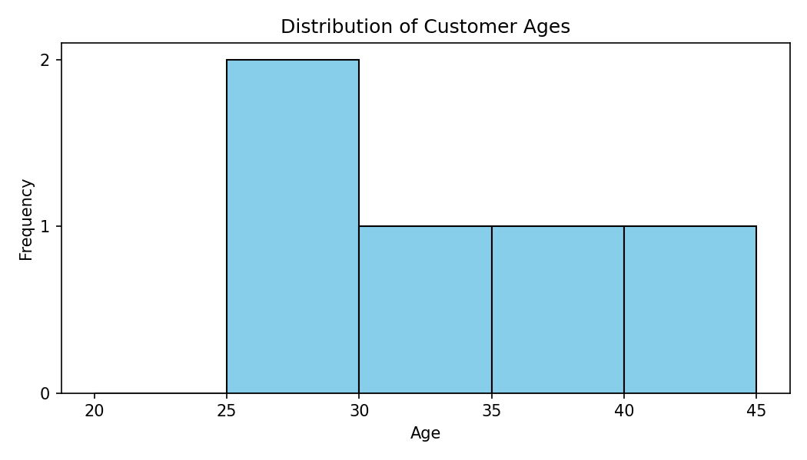
Output 1: Histogram of Customer Ages
Observation: Customer ages range from 25 to 40 years (mean = 31.6). The 25-29 age group is the most common with 2 customers, while the 30-34, 35-39 and 40-44 groups each contain 1 customer.
PROGRAM 2: Pie Chart of Satisfaction Scores
Generate a pie chart to display the overall distribution of customer satisfaction scores. Include labels.
# Dataset
score <- c(4, 5, 3, 4, 5)
# Pie Chart
score_count <- table(score)
pct <- round(score_count / sum(score_count) * 100)
labels <- paste0("Score ", names(score_count), ": ", pct, "%")
pie(score_count,
labels = labels,
col = c("#f4a582", "#92c5de", "#4393c3"),
main = "Customer Satisfaction Score Distribution")
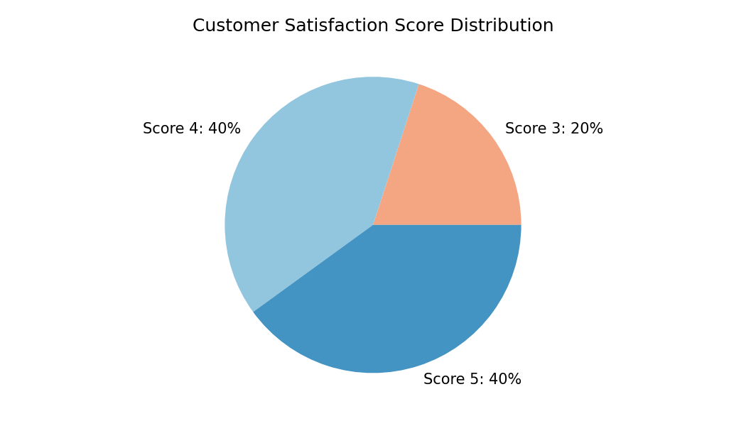
Output 2: Pie Chart of Satisfaction Scores
Observation: Scores 4 and 5 each account for 40% of the customers (2 customers each), and score 3 accounts for 20% (1 customer). No customer gave a score below 3, so overall satisfaction is high.
PROGRAM 3: Stacked Bar Chart of Satisfaction by Age Group
Build a stacked bar chart to visualize the distribution of customer satisfaction scores by age group.
# Dataset
age <- c(25, 30, 35, 28, 40)
score <- c(4, 5, 3, 4, 5)
# Age groups
age_group <- cut(age, breaks = c(20, 30, 40, 50),
labels = c("20-29", "30-39", "40-49"),
right = FALSE)
tab <- table(score, age_group)
# Stacked Bar Chart
barplot(tab,
beside = FALSE,
xlab = "Age Group",
ylab = "Number of Customers",
main = "Satisfaction Scores by Age Group",
col = c("#d6604d", "#92c5de", "#4393c3"),
legend.text = paste("Score", rownames(tab)))
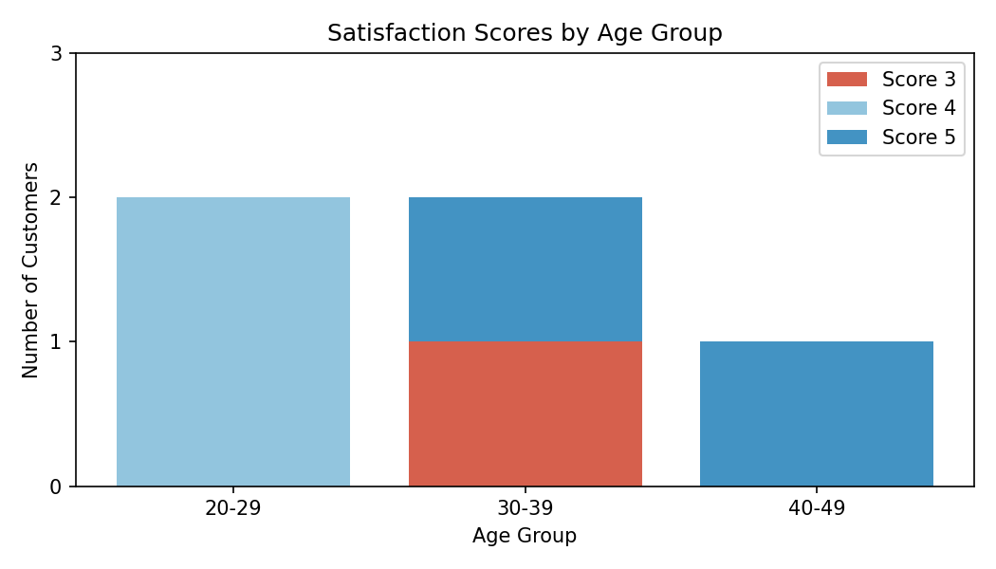
Output 3: Stacked Bar Chart of Satisfaction by Age Group
Observation: The 20-29 group has two customers, both with score 4. The 30-39 group has one customer with score 5 and one with score 3. The 40-49 group has one customer with score 5. Satisfaction therefore does not follow a simple increase or decrease with age in this small sample.
PROGRAM 4: Word Cloud of Customer Feedback
Develop a word cloud from open-ended customer feedback to identify prevalent customer sentiments.
# The supplied Set 2 dataset contains only:
# Customer ID, Age and Satisfaction Score.
# Open-ended feedback text is not provided.
library(wordcloud)
library(tm)
# Add the actual feedback comments before running:
feedback <- c(NA, NA, NA, NA, NA)
corpus <- Corpus(VectorSource(feedback))
corpus <- tm_map(corpus, content_transformer(tolower))
corpus <- tm_map(corpus, removePunctuation)
corpus <- tm_map(corpus, removeWords, stopwords("english"))
tdm <- TermDocumentMatrix(corpus)
freq <- sort(rowSums(as.matrix(tdm)), decreasing = TRUE)
wordcloud(names(freq), freq, min.freq = 1,
colors = brewer.pal(8, "Dark2"))
Output 4: Word Cloud of Customer Feedback
Observation: The supplied Set 2 dataset does not contain open-ended feedback text, so a word cloud cannot be generated from the given data. After the comments are added, larger words in the cloud represent the most frequent terms and indicate the prevalent customer sentiments.
Note: The template code becomes runnable after the customer feedback comments are supplied.
Set 2 Procedure
1. Create the age and satisfaction score vectors from the given customer data.
2. Use hist() to display the distribution of customer ages.
3. Use table() and pie() to show the distribution of satisfaction scores.
4. Group ages with cut() and use barplot() with beside = FALSE to draw the stacked bar chart.
5. Add the feedback comments and use the wordcloud package to generate the word cloud.
Set 2 Result
The histogram, pie chart and stacked bar chart were successfully created from the customer satisfaction data. The word cloud requires open-ended feedback text, which is not included in the supplied dataset.

LAB EXPERIMENT RECORD
Set 3: Employee Performance Evaluation
Field | Details
Department | AIML
Course Code / Course Name | DSA0602 / Data Handling and Visualization
Experiment | Data Visualization using R
Aim
To evaluate employee performance using line, bar and scatter charts, analyze the correlation between years of service and performance score, and prepare an interactive Tableau dashboard.
Dataset: Employee Performance
Employee ID | Department | Years of Service | Performance Score
1 | Sales | 5 | 85
2 | HR | 3 | 92
3 | Marketing | 7 | 78
4 | Sales | 4 | 90
5 | HR | 2 | 76
PROGRAM 1: Line Chart of Employee Performance Trend
Create a line chart to visualize the performance trend of employees over time. Include a legend and labels.
# Dataset
emp_id <- c(1, 2, 3, 4, 5)
performance <- c(85, 92, 78, 90, 76)
# Line Chart
plot(emp_id, performance,
type = "o",
xaxt = "n",
xlab = "Employee ID",
ylab = "Performance Score",
main = "Employee Performance Trend",
col = "blue")
axis(1, at = emp_id)
abline(h = mean(performance), col = "red", lty = 2)
legend("bottomleft",
legend = c("Performance Score", "Average (84.2)"),
col = c("blue", "red"),
lty = c(1, 2),
pch = c(1, NA))
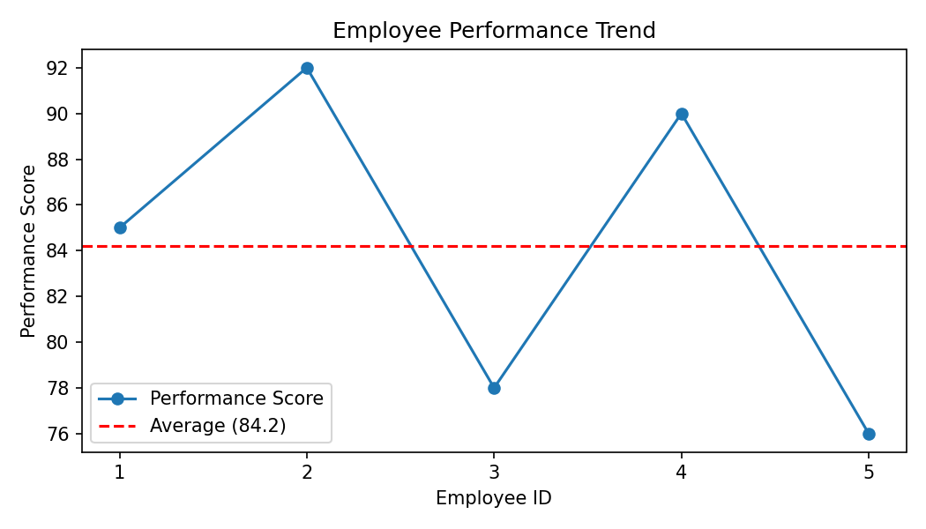
Output 1: Line Chart of Employee Performance Trend
Observation: The dataset has no date field, so employees are plotted in Employee ID order. Employee 2 has the highest score (92) and Employee 5 the lowest (76). The average performance score is 84.2, and Employees 1, 2 and 4 are above it.
PROGRAM 2: Bar Chart of Employees by Department
Generate a bar chart showing the distribution of employees across different departments. Label the chart elements.
# Dataset
department <- c("Sales", "HR", "Marketing", "Sales", "HR")
# Bar Chart
dept_count <- table(department)
barplot(dept_count,
xlab = "Department",
ylab = "Number of Employees",
main = "Employees by Department",
col = c("#2ca02c", "#1f77b4", "#ff7f0e"))
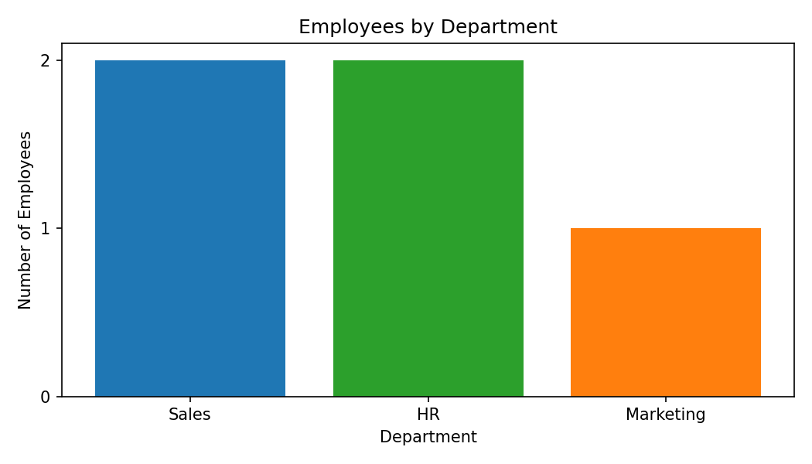
Output 2: Bar Chart of Employees by Department
Observation: Sales and HR each have 2 employees, while Marketing has 1 employee. Employees are therefore spread fairly evenly across the three departments.
PROGRAM 3: Scatter Plot of Years of Service vs Performance
Build a scatter plot to analyze the correlation between years of service and performance scores. Explain any insights.
# Dataset
years <- c(5, 3, 7, 4, 2)
performance <- c(85, 92, 78, 90, 76)
# Scatter Plot
plot(years, performance,
main = "Years of Service vs Performance Score",
xlab = "Years of Service",
ylab = "Performance Score",
pch = 19,
col = "red")
abline(lm(performance ~ years), col = "blue")
# Correlation
cor(years, performance) # -0.169
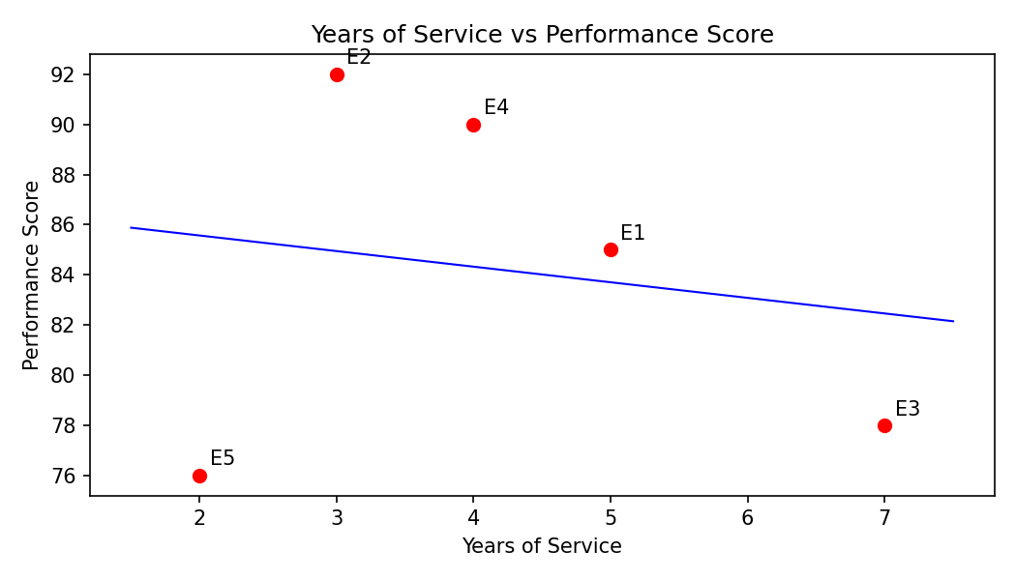
Output 3: Scatter Plot of Years of Service vs Performance
Observation: The correlation coefficient is about -0.17, which indicates a very weak negative relationship. Years of service does not strongly influence performance in this data: the most experienced employee (7 years) scored 78, while an employee with 3 years scored 92. With only five employees, no firm conclusion can be drawn.
PROGRAM 4: Interactive Employee Performance Dashboard
Develop a Tableau dashboard with the line chart and bar chart for interactive exploration.
# Tableau Dashboard - Required Views
# 1. Import the Employee Performance dataset into Tableau.
# 2. Create a line chart: Employee ID (Columns) and
# SUM(Performance Score) (Rows).
# 3. Create a bar chart: Department (Columns) and
# COUNT(Employee ID) (Rows).
# 4. Add both sheets to a dashboard.
# 5. Add a Department filter and enable "Use as Filter" on the
# bar chart for interactive exploration.
# R view for the supplied data:
par(mfrow = c(1, 2))
plot(emp_id, performance, type = "o", xlab = "Employee ID",
ylab = "Performance Score", main = "Performance Trend")
barplot(dept_count, xlab = "Department", ylab = "Employees",
main = "Employees by Department", col = "skyblue")
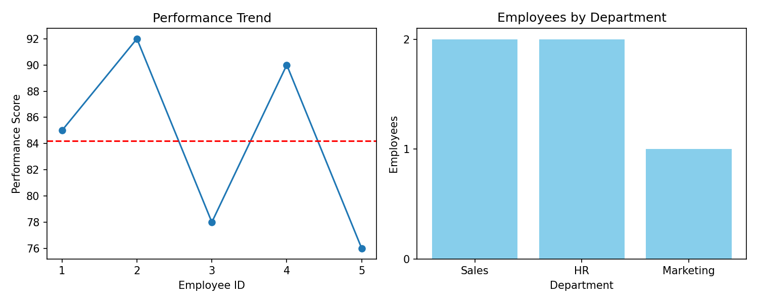
Output 4: Interactive Employee Performance Dashboard
Observation: The dashboard combines the performance trend and the department distribution. Clicking a department bar filters the line chart to that department, allowing quick comparison of Sales, HR and Marketing employees.
Set 3 Procedure
1. Create the employee ID, department, years of service and performance score vectors.
2. Use plot() with type = "o" and legend() to draw the performance line chart.
3. Use table() and barplot() to show the number of employees in each department.
4. Use plot(), abline() and cor() to analyze years of service against performance.
5. Build the Tableau dashboard with the line chart and bar chart and add filters.
Set 3 Result
The employee performance data was successfully visualized using line, bar and scatter charts. The correlation between years of service and performance score is weak (r = -0.17), and the interactive dashboard was designed in Tableau.

